How to reset password and reenable your account for ATLAS
- If you have forgotten your password or your account has been disabled after 5 incorrect attempts, click on the “Forgotten your password?” link
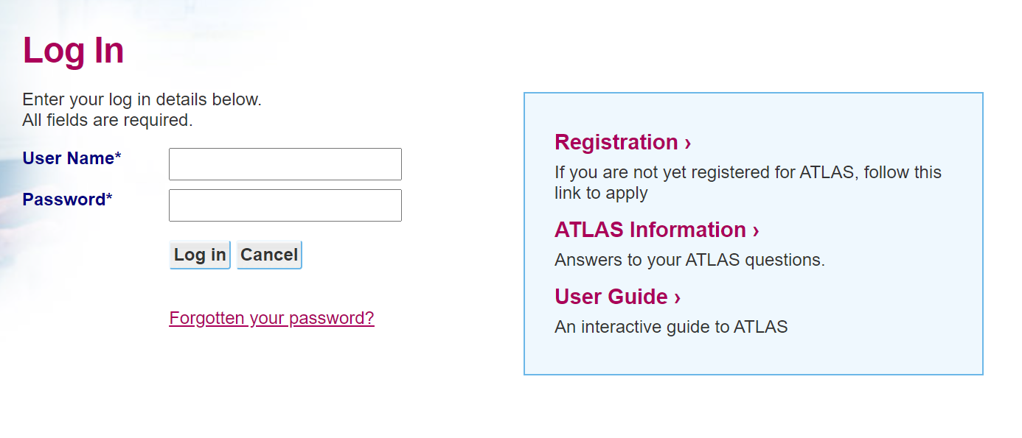
- On the Reset Password screen, please enter in your username, the postcode of your office as recorded in Atlas. You will also need to enter in the CAPTCHA. NOTE: The CAPTCHA is not case-sensitive, then click ‘Next’
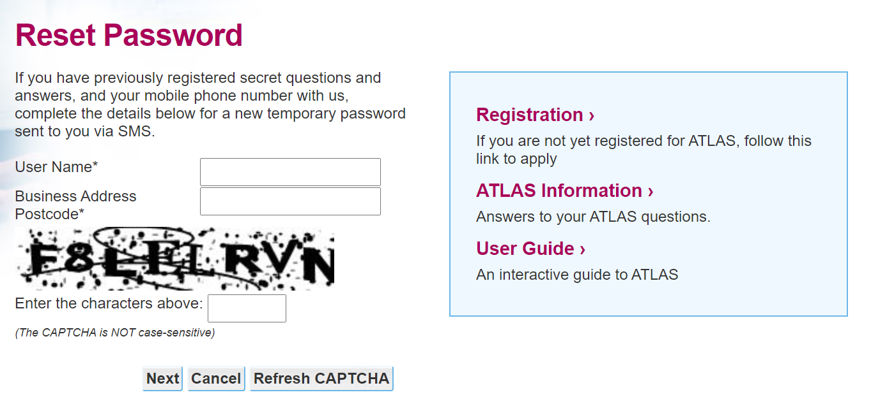
- You will then be prompted to enter in a One Time Pin (OTP) that will be sent via SMS to your registered mobile number in your Atlas profile
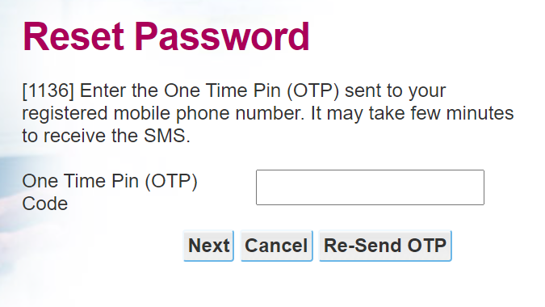
- If the password reset and account enablement is successful, the below message will be shown. Click on “Return to login”
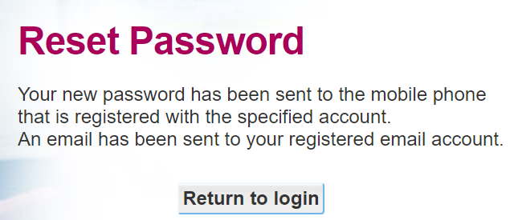
- Your new temporary password will be sent via SMS to your registered mobile phone number in your ATLAS profile. NOTE: The fullstop is not not part of the temporary password. As an example, the temporary password for the screenshot below is 3jdf1J7F and not 3jdf1J7F.
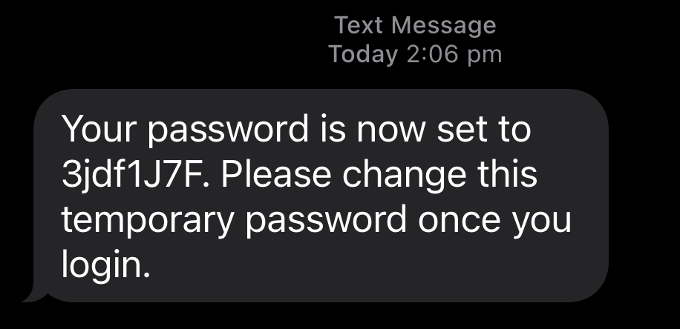
- You will also receive an email on your registered email in your ATLAS profile informing your that your password has been changed.
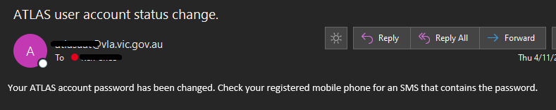
- Login using your temporary password sent to you via SMS
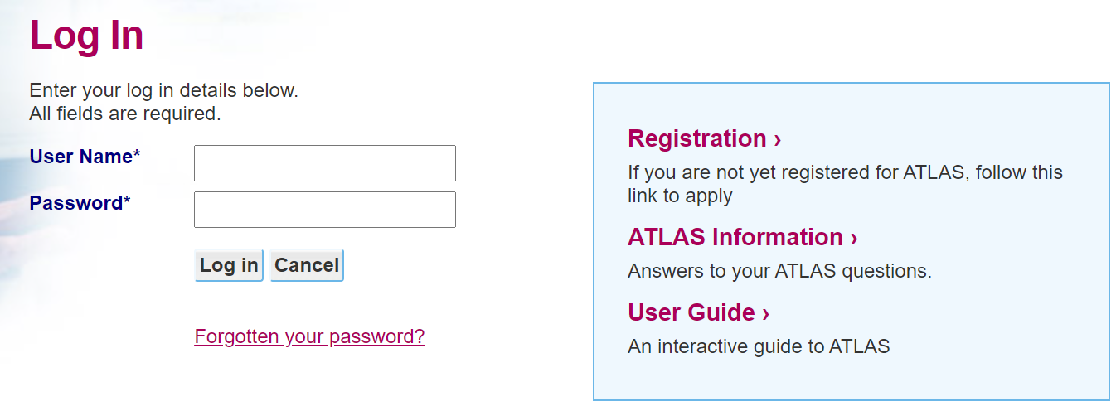
- When successfully entering in your username and temporary password, you will then be prompted to update your password to a password of your choice.
NOTE: Password must:
- be at least 8 characters long.
- contain at least 1 uppercase alphabetic character(s).
- contain at least 1 numeric character(s).
- be a stronger password. Do not use repeating patterns (e.g. aaaaa, 44444), sequences (e.g. abcdefg, 12345), personal words such as first name, last name or user ID, or obvious words like 'password' or 'secret'.
- 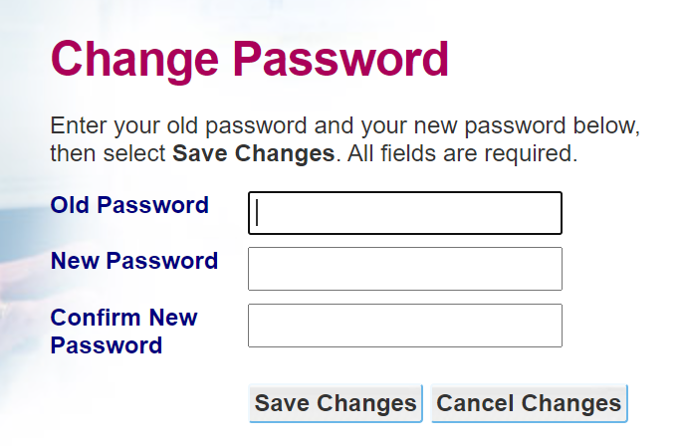
- After successfully setting a new password, you will be logged into ATLAS.

Troubleshooting

Enter in the wrong postcode
if you have entered in the wrong postcode that is associated to your office, you will be prompted that you have entered in the wrong postcode. Please check and ensure that you have entered in the correct postcode.
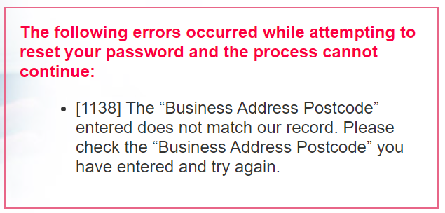

Enter in the wrong user name
If you have entered in the wrong username, you will be prompted that the user name you have entered does not match our record. Please check and ensure that you have entered in the correct username. If the issue persist please contact Legal Aid on 03 9269 0343
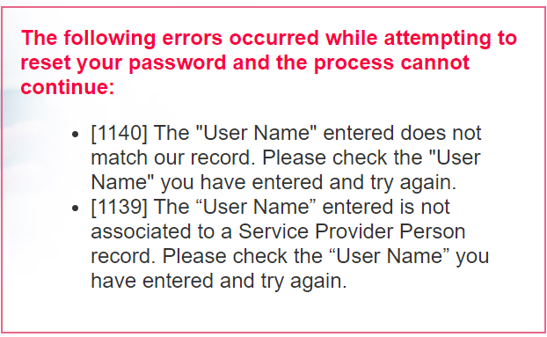

User name entered does not associate to a Service Provider Person
If you get the error message below, please contact Panels on 9606 5264
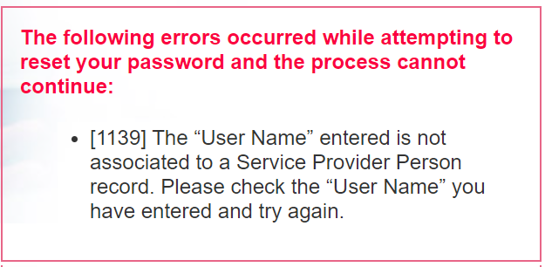

Enter in the wrong OTP
If you have entered in the wrong One Time Pin, you will be prompted that you have entered in the wrong OTP. Please check and ensure that you have entered in the correct OTP. If it’s still an issue, request for a new OTP by clicking on “Resend OTP”
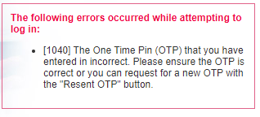

Did not receive the OTP SMS
If you did not receive the SMS, you can click on “Resend OTP”. Please allow about a minute or so for the SMS to be sent to your mobile number. Note that you can only request this 3 times before you are being reverted back to the initial login screen.

Still did not receive the OTP SMS on you phone
If you still have not receive the SMS after 3 attempts on “Resend OTP”, please contact your office ATLAS administrator to ensure that your mobile phone number is correct

Attempting to reset your password and reenable your account without an associated mobile phone number
You will get the below error message if you attempt to reset your password and/or reenable your account without an associated mobile phone number registered to your account. You will not be able to use the reset password feature without a mobile phone number. Please contact your office administrator to enter in a mobile phone number for your account.
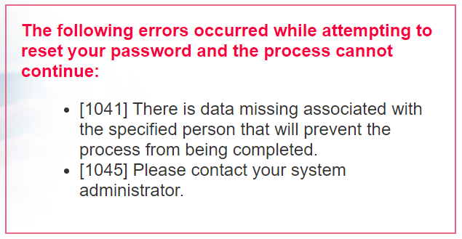

If you have deleted the SMS with your temporary password
If you have deleted the SMS with your temporary password, you will need to contact your office administrator or Legal Aid on 9269 0343 to have your password reset again. This is so that you can use that password to setup your new password.

